## Hey Kodi Installation

### Prerequisites

"Hey Kodi !" needs some prerequisites.

1. The only version of Kodi tested is "Kodi Martrix 19.3"
2. The dot net framework 4.8 must be installed on the machine. The "Hey Kodi" installer will propose you to download this library if it is not present.
3. You must have a microphone, and the microphone input should be the default Windows audio input.

To check that :

* Right click on the sound icon in the taskbar, select "Sound"

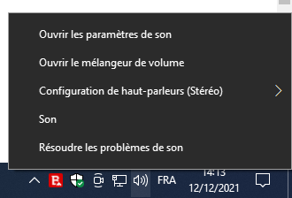

* In the "Recording" tab of the window that opens, right click on the microphone input and choose "set as default device"

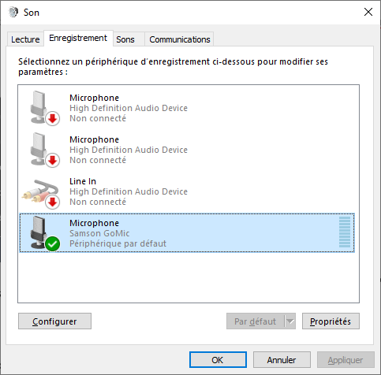

You can use this kind of remote control with microphone and air mouse:

<https://www.amazon.fr/gp/product/B0953VZPL3/ref=ppx_yo_dt_b_asin_title_o02_s00?ie=UTF8&psc=1>

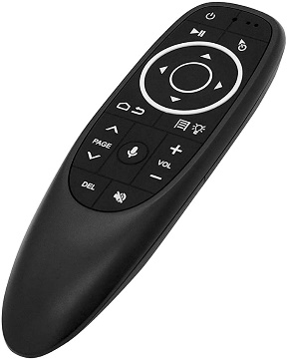

Or this one with a keyboard (QWERTY):

<https://www.amazon.fr/gp/product/B08L9C5BQD/ref=ppx_yo_dt_b_asin_title_o01_s00?ie=UTF8&psc=1>

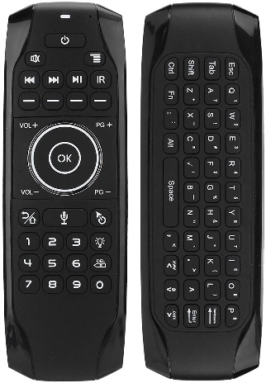

1. The application uses Windows speech recognition. This must be activated in the language setting. For it :

* Type "language" in the search bar, and click on "modify language and keyboard settings"

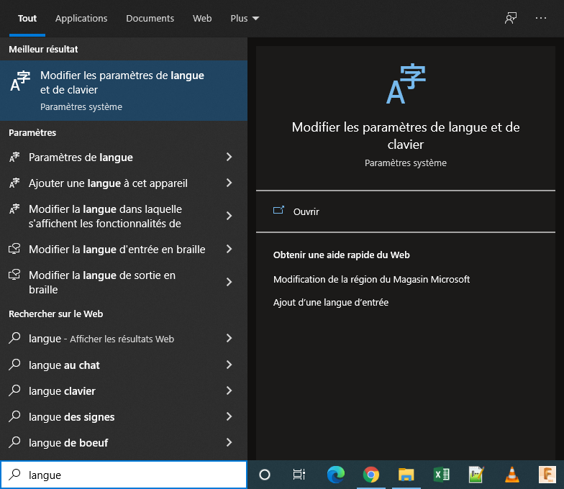

* Click on the "Options" button of the native language (English):

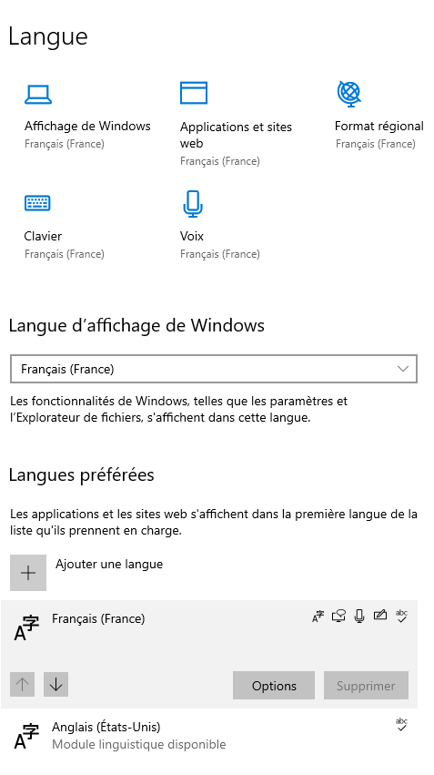

* Download missing modules:

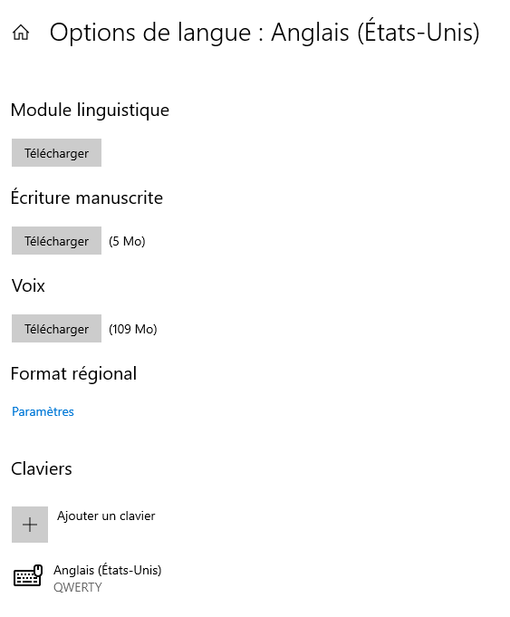

Note that we strongly recommend that you install US English (en-US) as a secondary language because "Hey Kodi!" will be able to use it to recognize the titles in English that will be dictated to it in the search feature for example.

1. Kodi Media Center must be able to receive orders via web service. This is set in the "Services" tab of Kodi configuration:

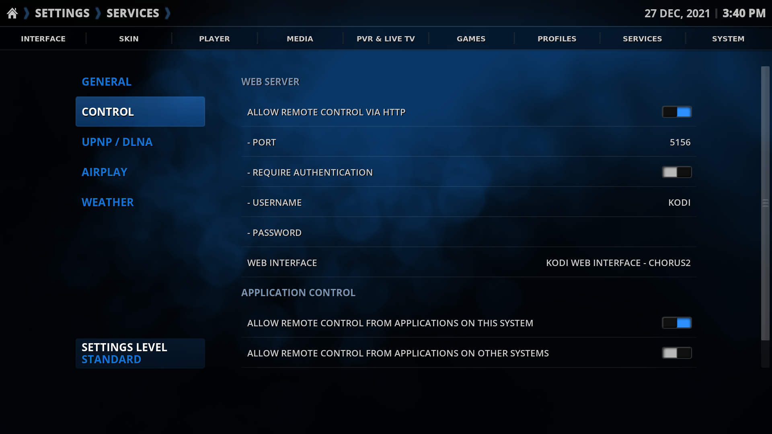

Note: The use of user / password identification causes bugs, probably on the Kodi side, but I have not been able to determine the cause yet.

### Note concerning the search command

The voice search control uses the "Global.Search" plugin from "Kodi Mediacenter". This extension must therefore be correctly installed and configured.

### Note on voice recognition

When launching "Hey Kodi" for the first time, you may get the following message:

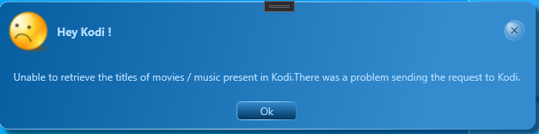

Indeed , "Hey Kodi" needs to retrieve the media list so that the voice recognition can work correctly (in particular for the “search” command).

You will therefore have to go to the configuration of "Hey Kodi" and to that of “Kodi Mediacenter” to configure the communication between the two applications as explained below before relaunching "Hey Kodi".

It will also be necessary to ensure that "Hey Kodi" launches after "Kodi Mediacenter".

### Configuration of "Hey Kodi!"

When launching "Hey Kodi" for the first time, you are advised to go to the settings screen by clicking on the gear:

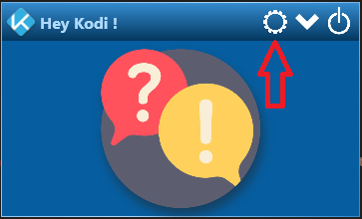

The configuration screen is then shown:

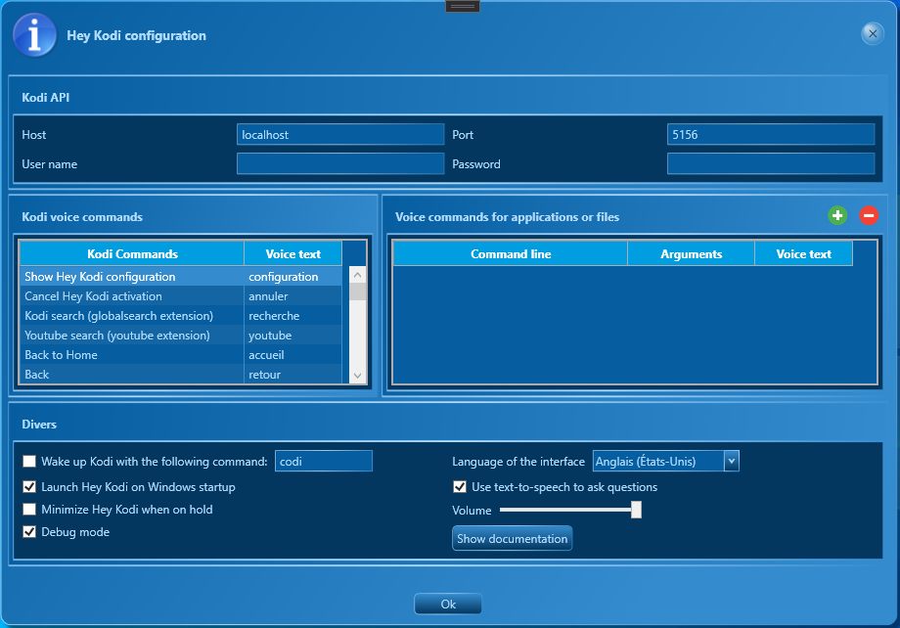

* **Kodi API :**

Network coordinates of the Kodi media center application (localhost = this machine), which will allow you to control it from "Hey Kodi!". Communication can be secured with a username and password.

* **Kodi voice commands:**

These are the various commands supported by "Hey Kodi! », and vocal texts that must be said to start them.

* **Voice commands for applications or files:**

These commands allow you to open files or launch applications. If the "Arguments" field contains "%%param%%", this value will be replaced by a voice parameter requested from the user before executing the command.

* **Wake up Hey Kodi with the following command:**

You can decide to wake up "Hey Kodi!" prior to any command (by saying "Kodi"), or you can launch the voice commands directly.

* **Start Hey Kodi when Windows starts:**

"Hey Kodi!" will be launched when Windows starts up.

* **Minimize Hey Kodi when on hold:**

Prevents "Hey Kodi!" obstructing the screen until you activate it with a voice command.

* **Debug mode**

Displays operating information of "Hey Kodi!" Useful for debugging.

* **Interface language**

App display language.

* **Use speech synthesis to ask questions:**

Text-to-speech is then used if it is available on the system.

* **Volume :**

Volume of sounds in "Hey Kodi!".

* **Show documentation :**

Shows this documentation.

### Troubleshoutings

TODO